**Module Title**

**Internet Technologies**

**Year**

**2024-25**

**Student Name: Sujal Chaudhary**

**Student ID: 10557**

**Week 10**

1. Write a program in Javascript to create variables to store numeric, float, string and Boolean values and show them in page with document.write() function.

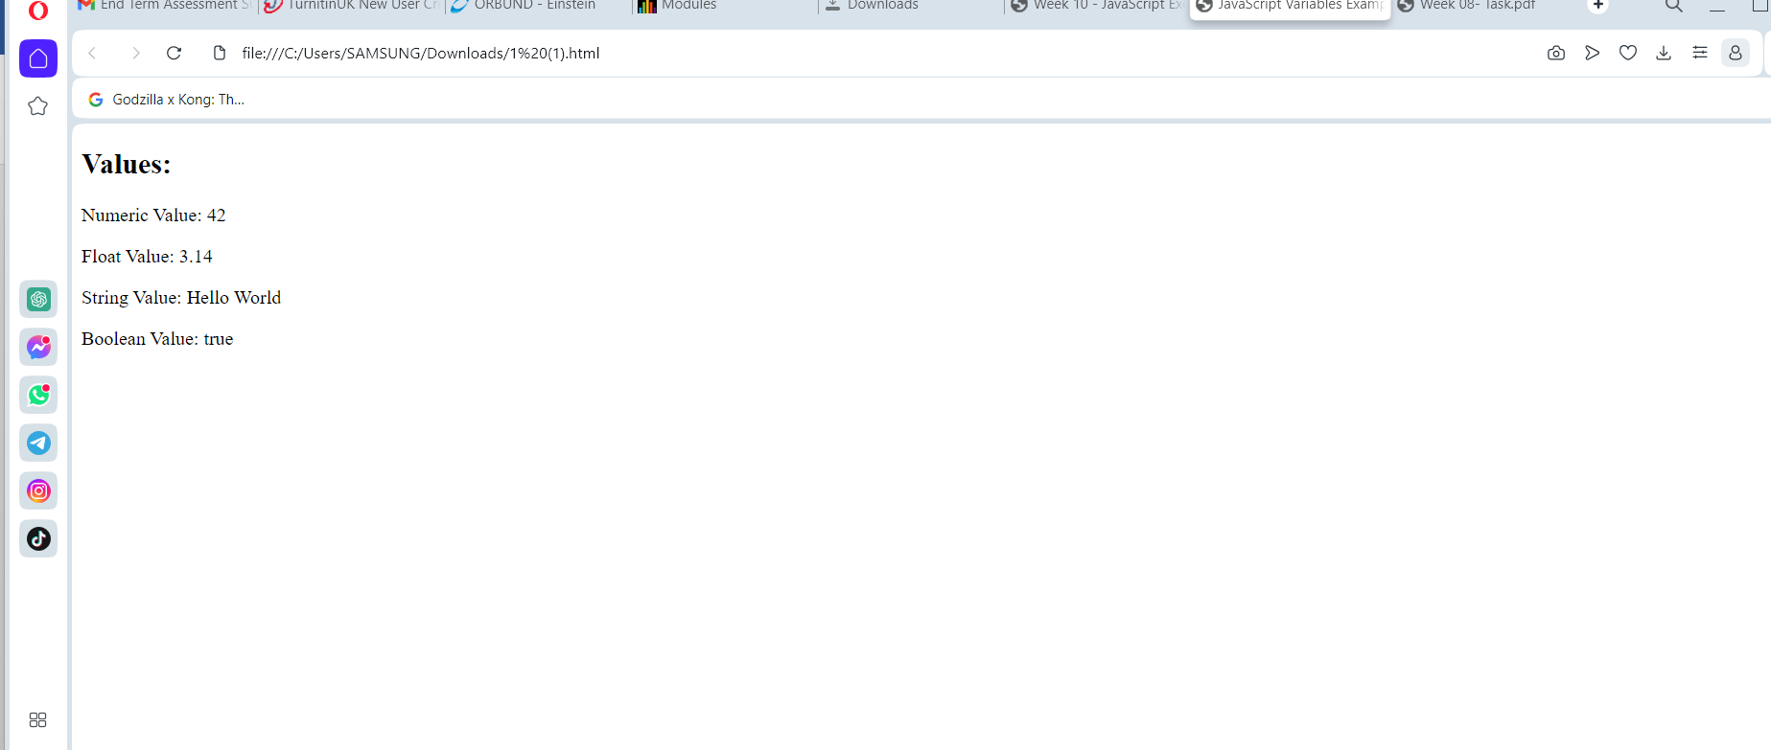

1. Write a program to input two data values for Your Name and Student Id in prompt dialog boxes and show them in alert dialog box.

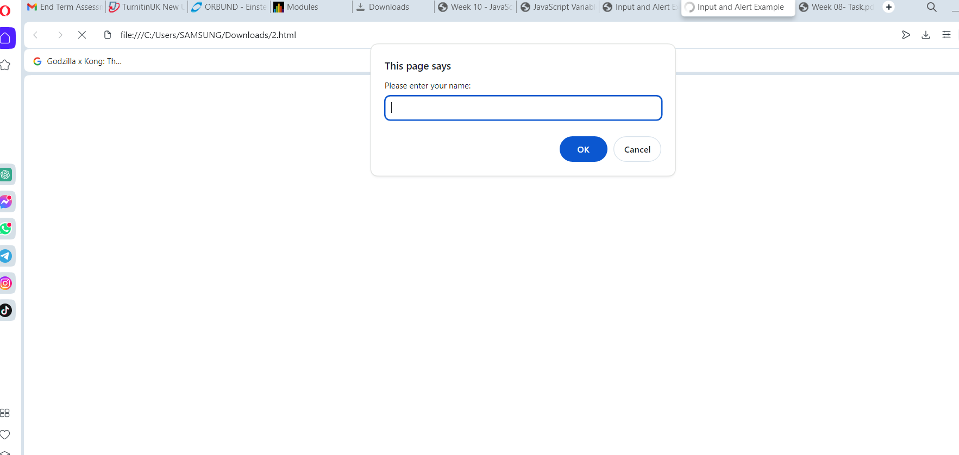

3. WAP to show the use if …. Else if …. else for following conditions:

a. For marks > = 80 and marks <=100, show Distinction

b. For marks >=60 and marks < 80, show First Division

c. For marks >=50 and marks < 60, show Second Division

d. For marks >=40 and marks < 40, show Fail

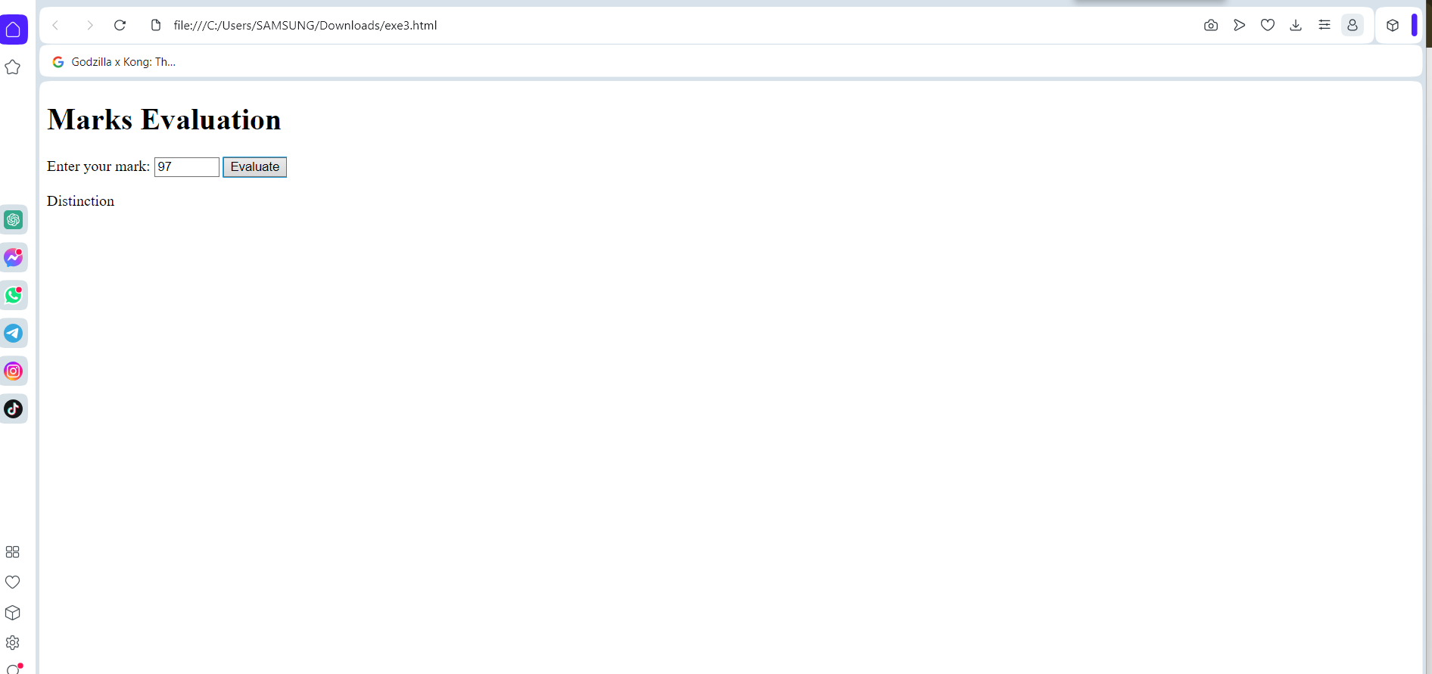

4. WAP to get number input with prompt dialog dox and show the Day using switch case

a. For Case 1, show Sunday

b. For Case 2, show Monday

c. For Case 3, show Tuesday

d. For Case 4, show Wednesday

e. For Case 5, show Thursday

f. For Case 6, show Friday

g. For Case 7, show Saturday

h. For default, show Invalid

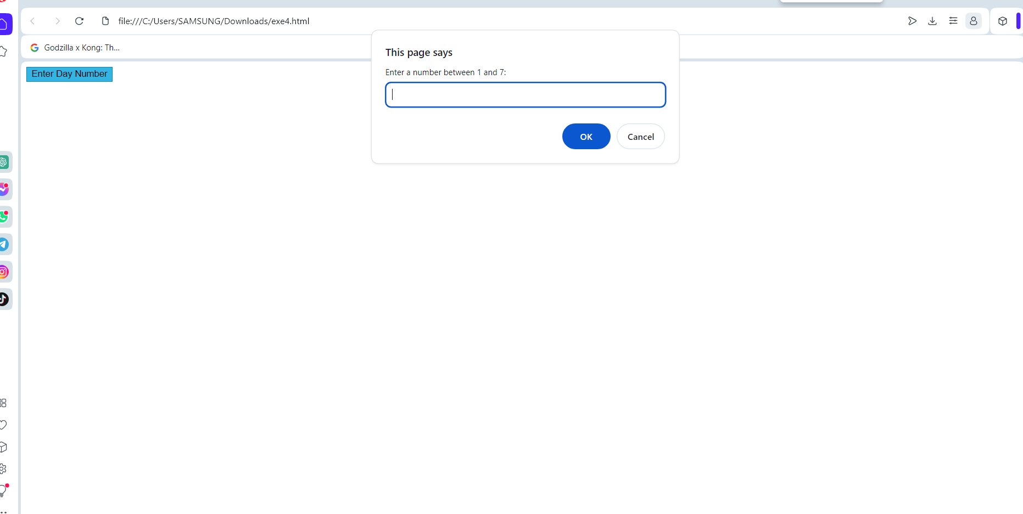

6. WAP to display multiplication number of 5 as follows: 5 * 1 = 5 5 * 2 = 10 5 * 3 = 15 ……………

……………. 5 * 10 = 50

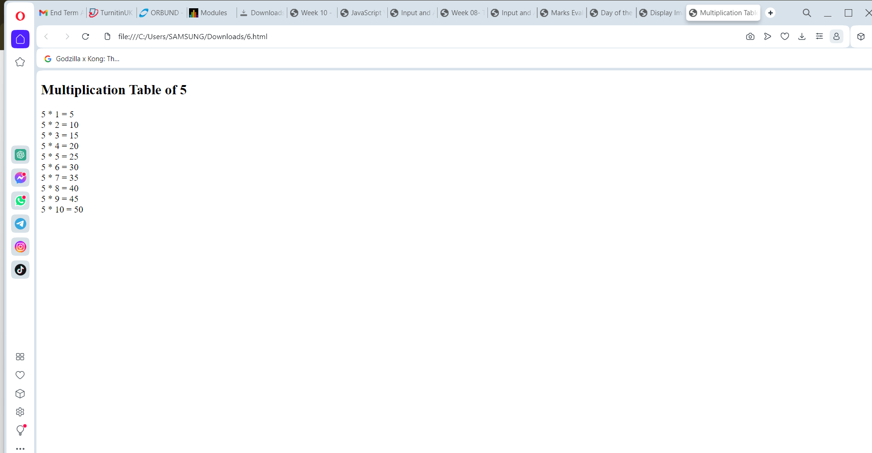

7. WAP in javascript using loop to display following table layout and with alternate background color on data rows

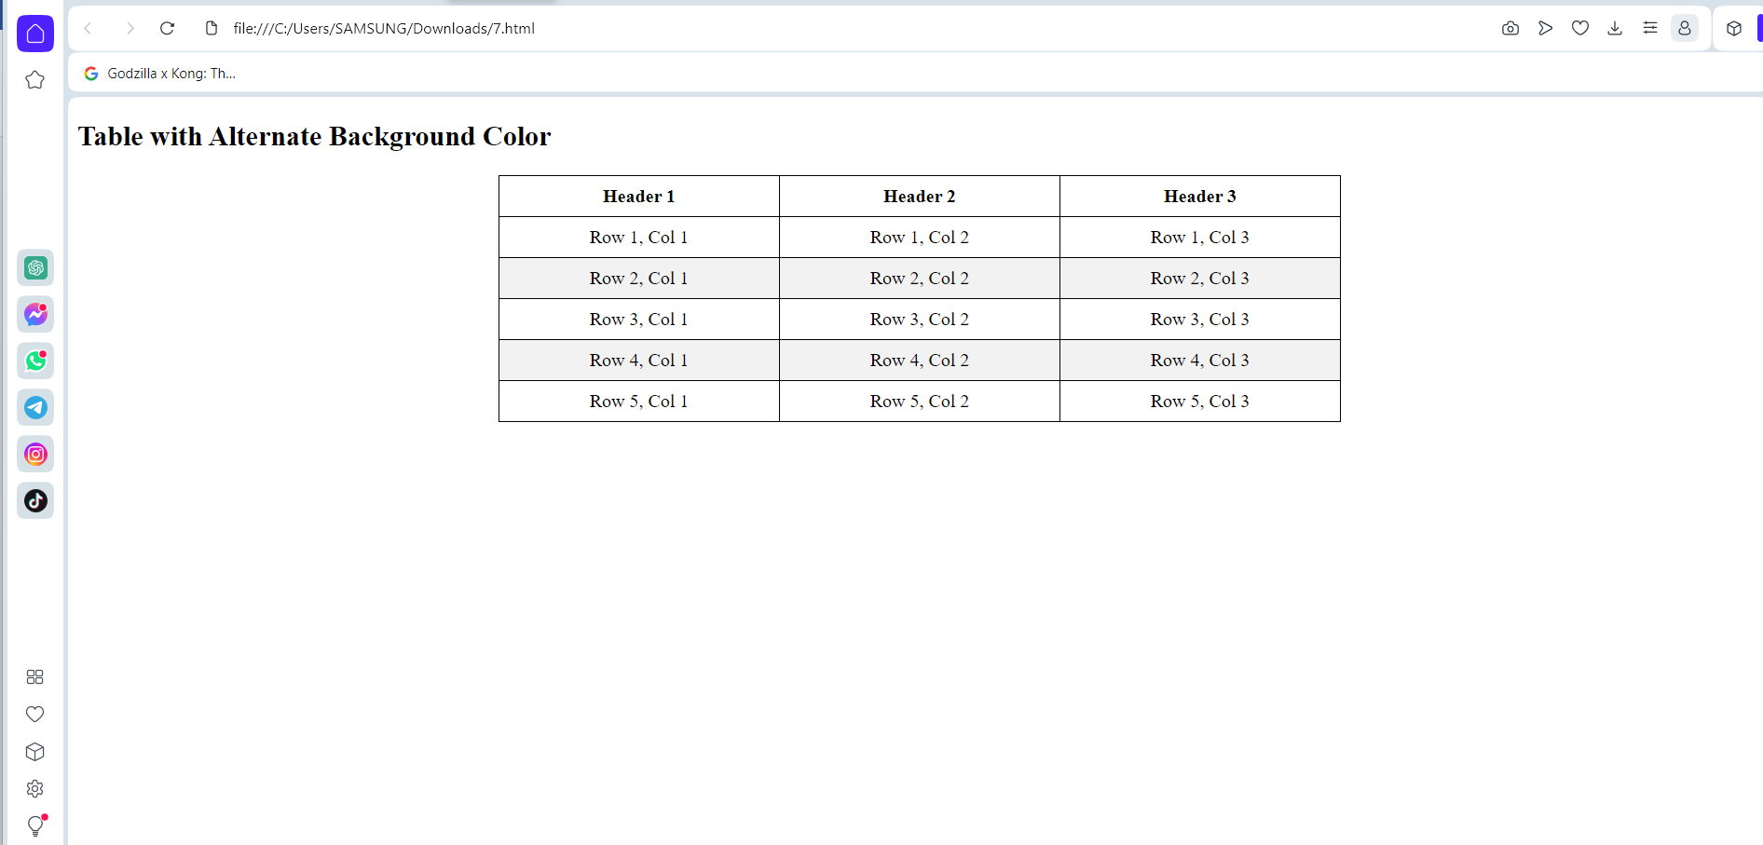

8. Write a simple JavaScript program to join all elements of the following array into a string. Sample array : myColor = ["Red", "Green", "White", "Black"]; Expected Output : "Red,Green,White,Black" "Red,Green,White,Black" "Red+Green+White+Black" Hint: Use these array functions myColor.toString(); myColor.join(); myColor.join('+');

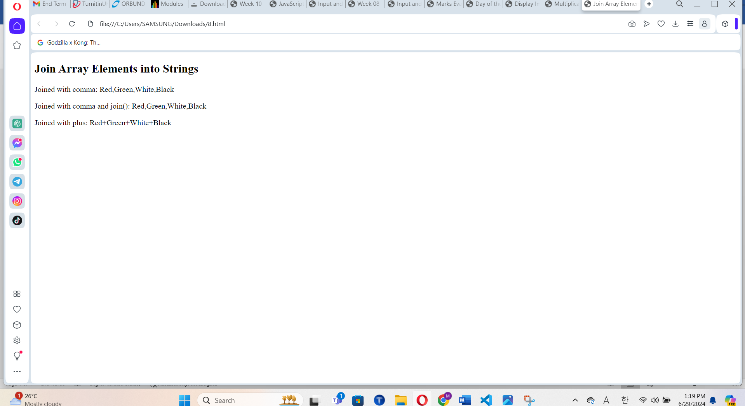

9. Write a JavaScript program to compute the sum and product of an array of integers.

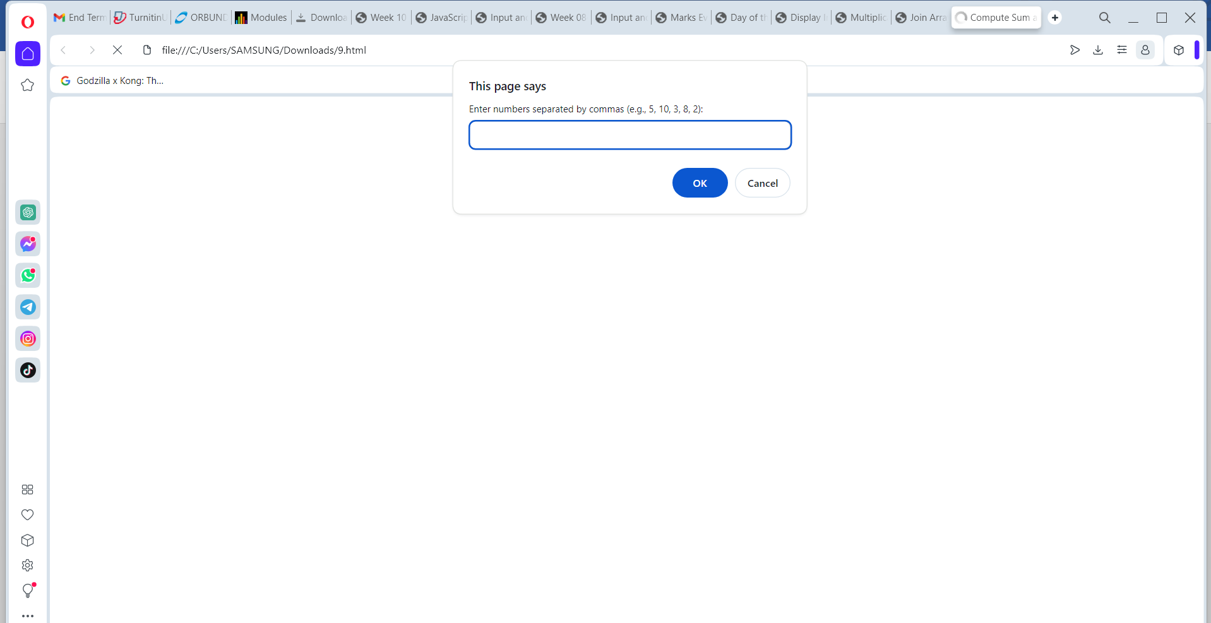

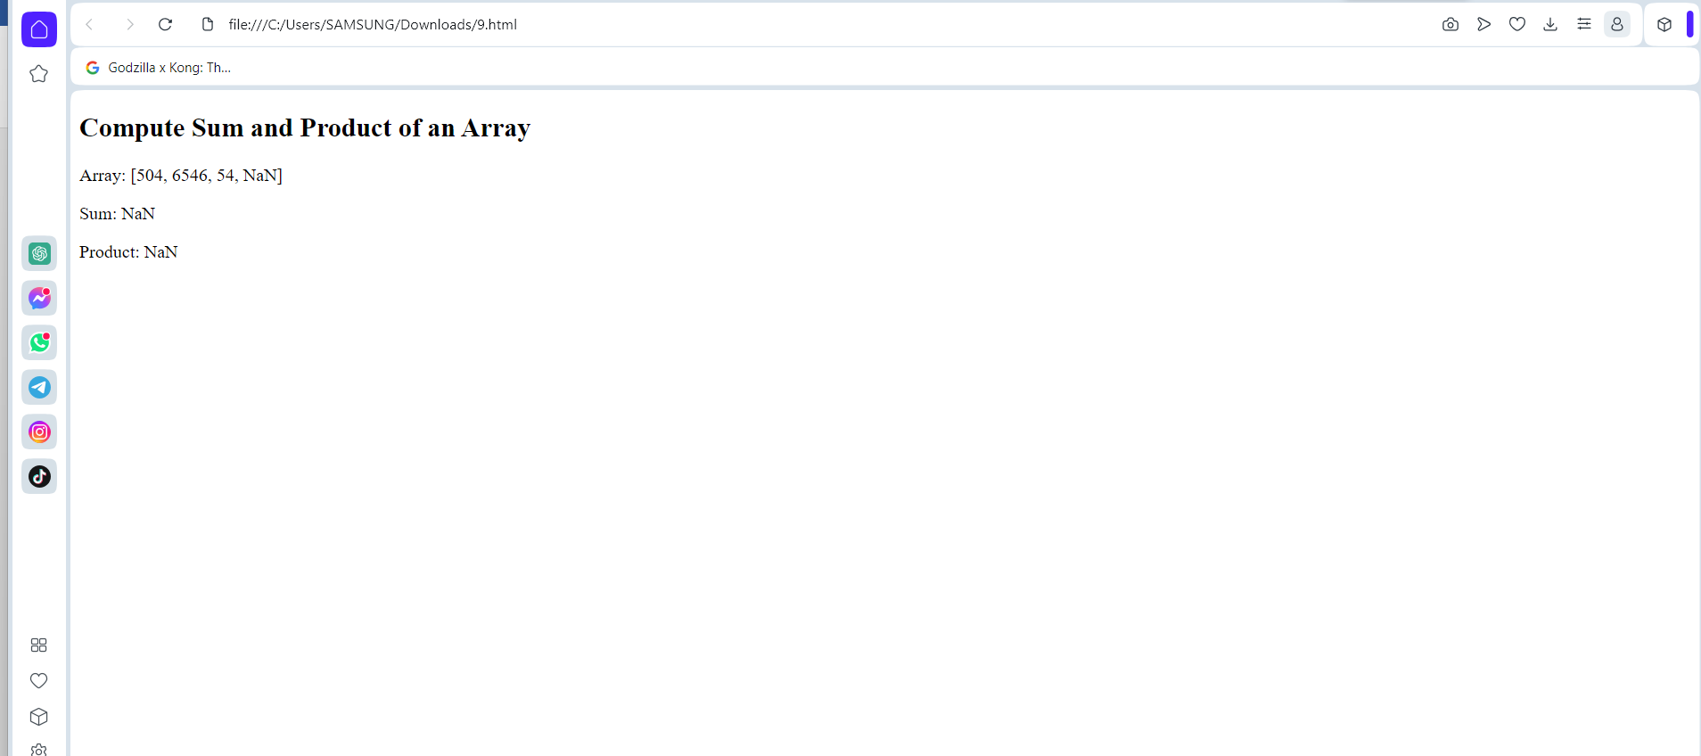

10. Write a Javascript function to calculate area of rectangle which accepts two parameters – length and breadth.

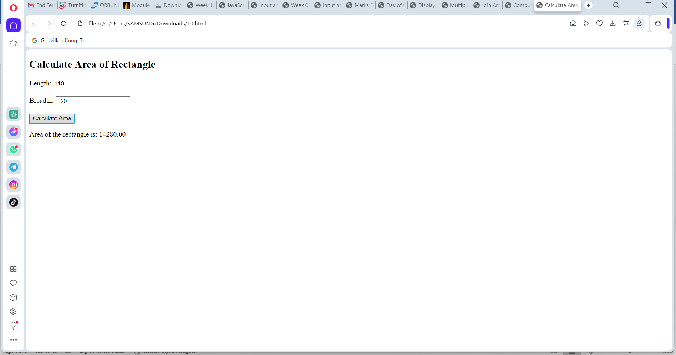

11. Write a JavaScript program to add items in an blank array and display the items using function. Sample screen:

